**The Music School Project**

School of Professional Studies, Clark University

Information Systems Analysis & Design

**The Music School Project**

**Business Case**

1. Mission Statement

Our School aims to provide high quality music education at an affordable price to our local community. Students of all age groups are welcomed in our music school for hands-on learning. We are adopting more modern technology to increase our resource and capacity to provide hassle free experience and provide a friendly learning atmosphere with our skilled professors. Our goal is to provide great learning experience for each of our students.

2. Cost Benefit Analysis

Option 1: SAAS – Jackrabbit

|  |  |  |  |
| --- | --- | --- | --- |
| Parameters | Implementation Cost for First Year | Implementation Cost for Second Year | Features & Benefits |
| Yearly Subscription Fees | 1020 | 1020 | Fast, reliable, and secured management software. |
| One Time Training Fees | 2000 | N/A | It automates time consuming tasks such as skills tracking, pos, streamline payroll etc. |
| Yearly Quickbooks Fees | 480 | 480 | Easy billing and payment processing |
| Yearly Wordpress Hosting Fees | 100 | 100 | Management of costumes and recital. |
| **Total Cost** | **3600** | **1600** | It provides website integration, online registration, class listing, parent portal access and many more essential features. |

SWOT Analysis

|  |  |
| --- | --- |
| **Strengths**   1. Payment is in the form of yearly subscription fees. 2. It provides more flexible and innovative features than its competitors. 3. Cost effective and high-tech work environment. | **Weaknesses**   1. Additional training cost for the software. 2. Limited or no customization is available. 3. High speed internet connection required. |
| **Opportunities**   1. Good opportunity for expansion of business. 2. Low cost for entry and exit. 3. One stop solution for all services required. | **Threats**   1. No offline access of software in the event of an outage or disaster. 2. Security concerns about lack of physical control of customer’s data. 3. Third party risk management. |

Feasibility of Software

|  |  |
| --- | --- |
| Type | Description |
| Operational | Easy operation processes, only one time training is needed for user which is feasible. |
| Economic | It has a fixed cost structure without any variable cost which makes this software economically feasible. |
| Technical | It does not require any additional hardware or software implementation for its usage which makes it technically feasible. |
| Schedule | This software is practically usable from day one, therefore it is schedule feasible. |

Option 2: Custom Build – PowerApps

|  |  |  |  |
| --- | --- | --- | --- |
| Parameters | Implementation Cost for first Year | Implementation Cost for Second Year | Features & Benefits |
| One Time Development Cost | 3000 | N/A | One time development cost, no yearly subscription fees. |
| Maintenance Cost | N/A | 600 | Data can be accessed offline. |
| One time Training Fees | 500 | N/A | Data is stored within the premises and is therefore more secure. |
| Yearly Quickbooks Fees | 480 | 480 | Low implementation cost and fulfills current scenario demand. |
| **Total Cost** | **3980** | **1080** | Customize the software in future as per the business requirement. |

*All the cost are in US Dollar ($)

SWOT Analysis

|  |  |
| --- | --- |
| **Strengths**   1. Better control of the resources. 2. Low and one time development cost. 3. Prioritization of the requirements. | **Weaknesses**   1. Lack of knowledge among the developers. 2. Time consuming for implementation. 3. More time to market. |
| **Opportunities**   1. Adaptive and customizable to future needs. 2. Less investment, high returns. 3. Better customer service. | **Threats**   1. High cost for customization in future. 2. Below par delivery of software package. 3. Cost for customization in future. |

Feasibility of Software

|  |  |
| --- | --- |
| Type | Description |
| Operational | The school operational performance will increase with this software which makes it operationally feasible. |
| Economic | The features required are bit expensive to implement in custom build software which makes it less economically feasible. |
| Technical | Since, the development of software package is outsourced with vendor having good technical skills, hence makes this software technically feasible. |
| Schedule | It requires some time to develop and implement which will increase the time to market and thereby making this option less feasible. |

Option 3: Custom Development – Joomla

|  |  |  |  |
| --- | --- | --- | --- |
| Parameters | Implementation Cost for first Year | Implementation Cost for Second Year | Features & Benefits |
| One Time Development Cost | 5000 | N/A | One time development cost, no yearly subscription fees for software package. |
| Yearly Maintenance Cost (Average 4 problems/year) | N/A | 400 | It has thousands of free extensions to customize the software package as per school’s specific needs. |
| Yearly Hosting Fees | 200 | 200 | Flexible and fully extensible. |
| Template Fees | 75 | 75 | Search-engine and mobile friendly. |
| Additional Plugins Fees | 1090 | 1090 | Multilingual, Secure. |
| **Total Cost** | **6365** | **1765** | Open-source software. |

SWOT Analysis

|  |  |
| --- | --- |
| **Strengths**   1. Open source software management system. 2. Flexible and easy to customize. 3. Multiuser permission levels. | **Weaknesses**   1. High cost of implementation. 2. Highly dependent on vendor’s infrastructure and software. 3. High and variable maintenance cost. |
| **Opportunities**   1. As it is an open source software system, more availability of technical talent. 2. Opportunity to cater multilingual customers. 3. Ability to add different plugin features. | **Threats**   1. Hidden cost for recovery and problem solving. 2. Strong competition from other software packages. 3. Security and compliance risk. |

Feasibility of Software

|  |  |
| --- | --- |
| Type | Description |
| Operational | As it is an open source software, risk of data breaching can hamper the school’s image which makes it operationally less feasible. |
| Economic | It has high and variable maintenance cost which could increase as the school grows and thereby making this option less feasible. |
| Technical | Easy and high availability of technical talent makes this software package technically feasible. |
| Schedule | This software implementation needs some time development time, therefore makes it less feasible than off-the-shelf software packages. |

3. Best Option

I would choose the option 1: SAAS – Jackrabbit because of the following reasons:

* It provides all the required features and functionalities ideal for the music school project.
* Cost of implementation is lower as compared to other software packages.
* It guarantees the 99.9% system uptime.
* This software can be used from any device anytime and from anywhere in the world with a good internet connection.
* Since the requirements of music school are very standard and does not require any custom solutions, we can choose the SAAS – Jackrabbit as the software package for the music school.

**Functional Decomposition Diagram**

Fig. 1 Functional Decomposition Diagram

**Business Requirements**

|  |  |
| --- | --- |
| **Rating** | **Description** |
| High | 1. The music school should create a website so that more people can know about its services. 2. The website should allow the students to register online for the class. 3. Need to on-board more advanced software package to scale the business and run it securely. 4. The system should provide the platform for students to view all the courses available. 5. The system must provide the scalability to cater 150 or more students. 6. School should be able to attract and hire more professional teachers. 7. The system should provide the flexibility to the students to select one or more classes. 8. The system should provide an interface to accept electronic payments. |
| Medium | 1. The website must have an interface for all feedback. 2. The system should have a secured student portal for accessing class recitals. 3. Automatic generation of e-mail related to important tasks and schedules. 4. The system should provide seamless integration with QuickBooks application. 5. The class roaster for every staff member and students should be stored in the system. 6. The system should facilitate both online(recorded) and in-person mode of teaching for students. 7. The school should provide a dashboard about different metrics of the business operations. |
| Low | 1. The billing system should automatically generate bi-weekly payment statements for each student and staff. 2. To attract investment and enrich student experience, school should organize more chorus, workshops, and bands. 3. The system should be able to categorize students by age, hobbies, personal needs, and match the right teachers and courses. |
| Future | 1. The school should collaborate with local government to raise a fund of $12000. 2. The school should have a mobile application for parents. |

**User Story for Requirements**

1. As a student, I want a website of the music school so that I can know more about the offerings of music school.
2. As a student, I want the class registration process to be online so that I have the flexibility to enroll for the classes from anywhere.
3. As a director, I want more sophisticated software for the school, so that I can utilize it to run the business smoothly.
4. As a student, I want to see various offerings in the course catalogue, so that I can choose my course accordingly.
5. As an administrator, I want to have flexibility to manage more students in the system so that the music school can grow organically.
6. As a director, I want to attract and hire more talented music teachers so that the students will have a great experience and learning.
7. As a student, I want to have the flexibility to enroll for one or more classes so that I can plan my schedule.
8. As a parent, I want an interface so that I can make the payment digitally from anywhere anytime.
9. As an administrator, I want to take reviews from the staff and student regularly so that I can improve our operations management.
10. As a student, I want to access my class recitals securely.
11. As an administrator, I want to have a system to generate automatic email notifications to students and staff so that they can manage their schedule efficiently.
12. As an accountant, I want a full featured and financial management tool so that I can keep track of all the financial transactions.
13. As an administrator, I want details of staff and students at one place so I can access them easily.
14. As a student, I want the flexibility to attend the classes either in-person or online so that I can attend the lectures without any disruption.
15. As an administrator, I want the system to provide different metrics of the business so that I can analyze the area which needs the attention and improvement.
16. As an accountant, I want the system to automatically generate bi-monthly financial statements for students and staff so that the financial transactions are done in time.
17. As a director, I want to organize more chorus and workshops so that I can attract investments and enrich student experience.
18. As an administrator, I want the system to place students according to their age, hobbies, and personal needs so that they can get the best teacher based on their preference.
19. As a director, I want to raise the fund of $12000 from local government so that I can improve existing infrastructure of the school.
20. As a parent, I want to track my child’s schedule and progress through a mobile application so that the entire process is convenient for me.

**Context Diagram**

Fig. 2 Context Diagram of the System

**Data Flow Diagram**

Fig. 3 Data Flow Diagram

**Sequence Diagram**

Fig. 4 Sequence Diagram for Adding class

**Decision Tree**

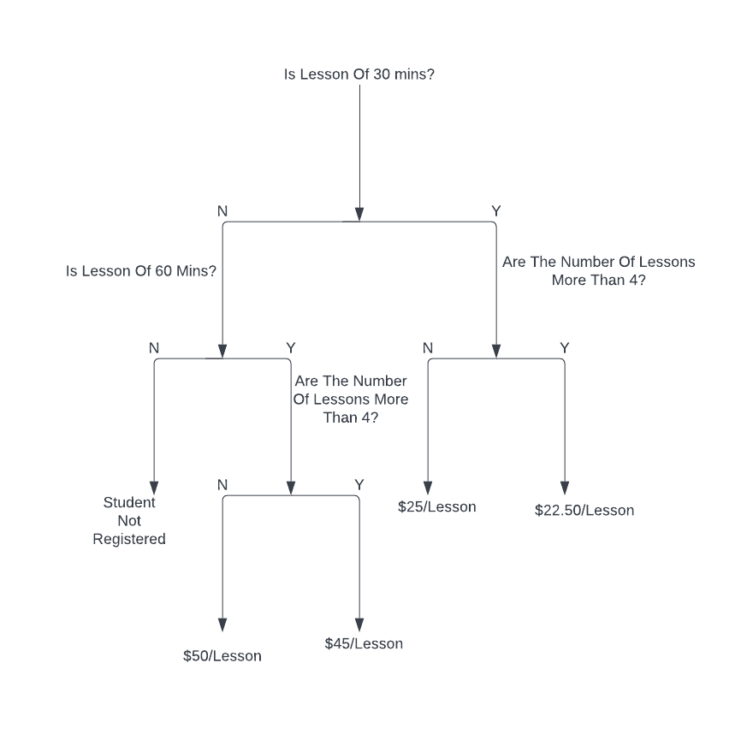

Fig. 5 Decision Tree on how to determine bill

**References**

[**https://www.jackrabbitclass.com/**](https://www.jackrabbitclass.com/)

[**https://www.joomla.org/**](https://www.joomla.org/)

[**https://www.wrike.com/blog/how-write-business-requirements-document/#Business-requirements-document-example-and-template**](https://www.wrike.com/blog/how-write-business-requirements-document/#Business-requirements-document-example-and-template)

[**https://www.agilealliance.org/glossary/user-story-template/**](https://www.agilealliance.org/glossary/user-story-template/)